Advanced Algebra Name: ____________________

Chapter 7 Retest Period: ________

7.1 (8) In questions 1 – 4, first write the expression as a radical/rational. Then evaluate.

1. 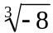 2. 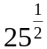

3. 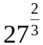 4. 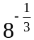

In questions 5 – 8, simplify the expression.
7.2 #1 (4)

5. 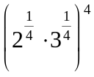 6. 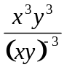

7.2 #2 (2) 7.2 #3 (2)
7. 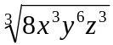 8. 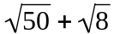

7.3 #1 (6)
In questions 9 – 12, let f(x) = x – 1 and g(x) = 2x, perform the indicated operation and state the domain.
9. 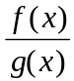 10. 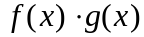

domain: _________________________ domain: _________________________

12. 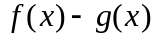
domain: _________________________

7.3 #2 (2)
11. 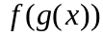

domain: _________________________

7.4 #1 (4)
In question 14, verify that f and g are inverses.
14. f(x) = 2x – 2, g(x) = 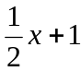

7.4 #2 (6) In question 13, find the inverse.
13. 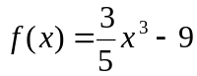
In questions 15 – 16, graph and state if the inverse is a function.
15. 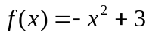 16. 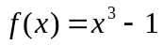
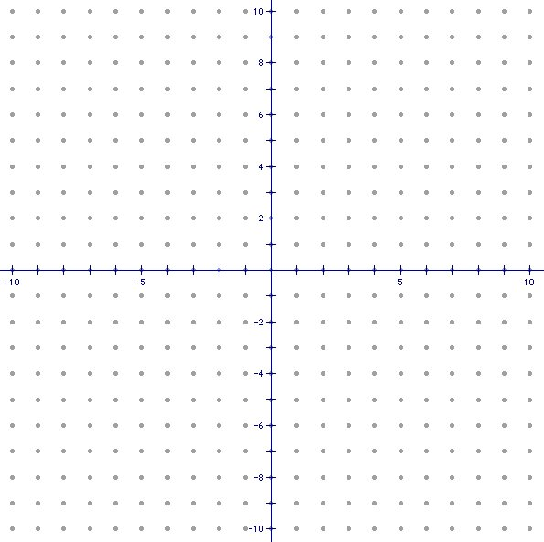

Inverse a function? _____ Inverse a function? _____

7.5 (10)In questions 17 – 18, graph and state the horizontal shift, vertical shift, domain, and range.

17. 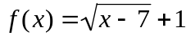 18. 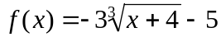

Horizontal Shift:_________ Horizontal Shift:_________
Vertical Shift:___________ Vertical Shift:____________
Domain: _______________ Domain: _______________
Range: _________________ Range: _________________

7.6 (12) In questions 19 – 22, solve the equation. Check for extraneous solutions.

19. 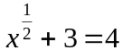 20. 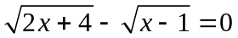

21. 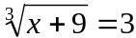 22. 